**CORRUPTION EXPLORATIONS:**

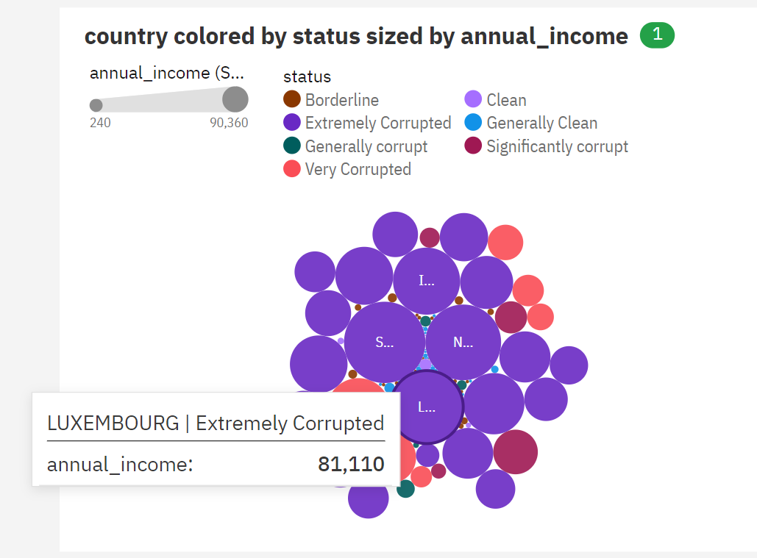

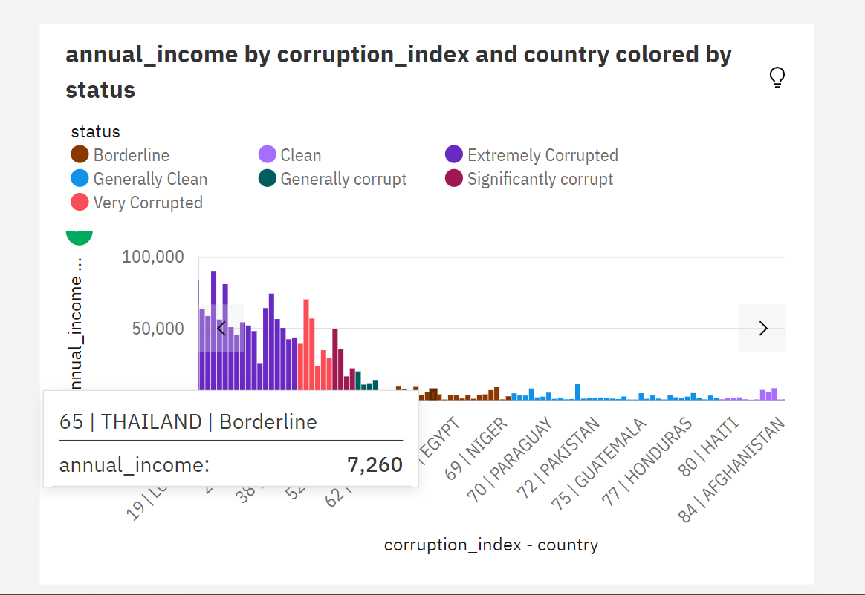

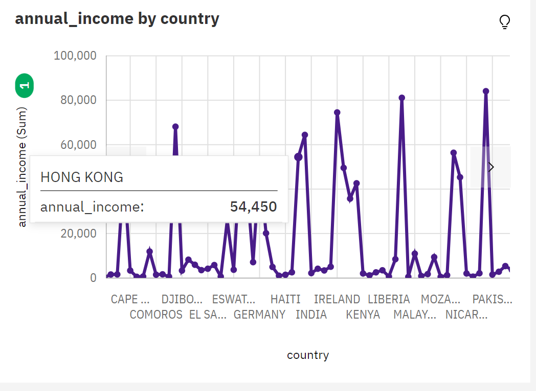

**For more explorations visit the link:**

https://us1.ca.analytics.ibm.com/bi/?perspective=explore&pathRef=.my_folders%2Fcorruption%2Bexploration&subView=model0000018a3b8573b4_00000004